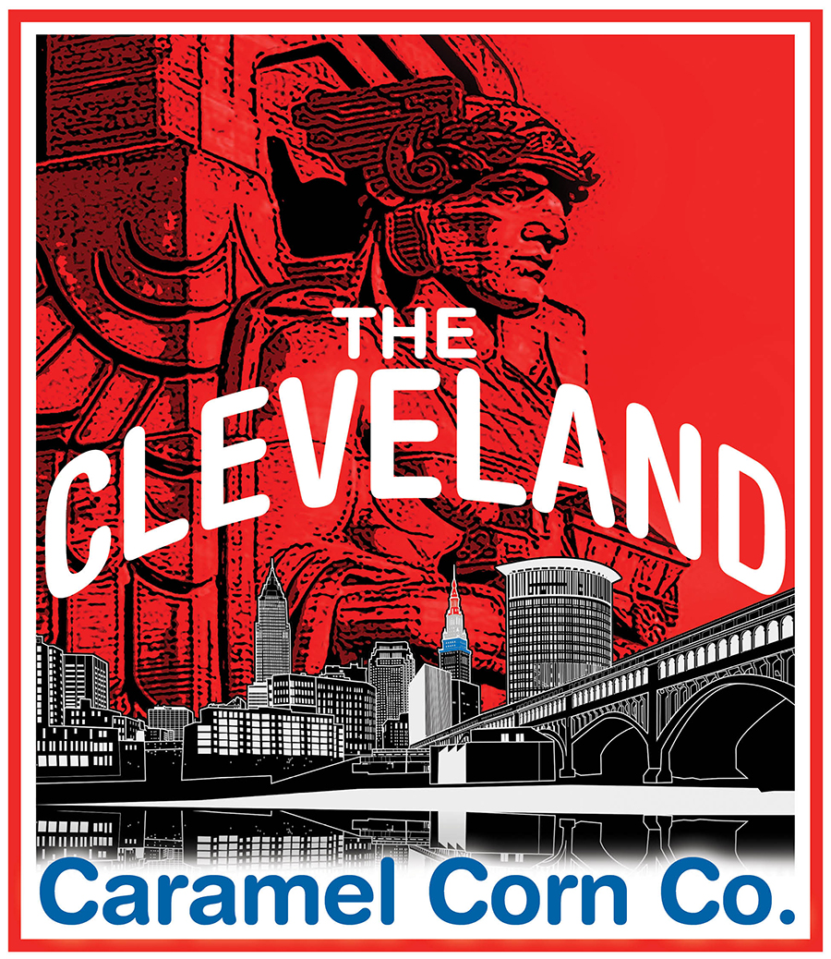

THE CLEVELAND
CARAMEL CORN CO.
theclecaramelcornco.com (440) 846-1727

~ GOURMET POPCORN FUNDRAISER APPLICATION FORM ~

ORGANIZATION INFORMATION: | COORDINATOR:
NAME: | EMAIL:
ADDRESS: | CONTACT NUMBER:
CITY: | CONTACT PREFERENCE:
STATE, ZIP: | NOTES:

FUNDRAISER INFORMATION: | TARGET GOAL (OPTIONAL):
TARGET START DATE: | TARGET END DATE:
APPROXIMATE GROUP SIZE: | OPTION ‘A’ Y/N:
POPCORN DELIVERY DATE: | OPTION ‘B’ Y/N:
*PLEASE ALLOW 10 DAYS AFTER YOUR CAMPAIGN END DATE FOR ORDER FULFILLMENT* | DELIVERY/PICK UP PREFERENCE:

The Cleveland Caramel Corn Co. Fundraising program is reserved for tax exempt, non-profit organizations. We are required to verify your tax exempt status prior to committing to or starting your fundraising campaign. | NOTES:
NAME OF NON-PROFIT:
TAX EXEMPT NUMBER:

TO THE BEST OF MY KNOWLEDGE, I AGREE THAT ALL INFORMATION SUBMITTED ON THIS
APPLICATION IS ACCURATE. SIGNATURE OF COORDINATOR:

